LAB SUBMISSION- Dina Bosma-buczynska
Multi-App Integration: Discord + Airtable Logger
Note: This lab was completed using Airtable instead of Google Sheets. All functionality and success criteria remain the same.

Use Case and Backstory
As an AI consultant, client questions and requests arrive through Discord on a daily basis. Manually copying these messages into a tracking spreadsheet is time-consuming and error-prone. This lab automates that process by building a workflow in n8n that listens for incoming Discord messages and logs them automatically to a structured Airtable base.

The goal is to eliminate manual data entry and create a reliable, searchable log of client questions that can be used for follow-up, response time analysis, and identifying common patterns over time.

This pattern, one external event triggering automatic data logging across multiple apps, is one of the most common and valuable automation patterns in real-world consulting and business operations.

Workflow Overview
The workflow connects three nodes in sequence:

Manual Trigger (simulates Discord message)
|
v
Edit Fields / Set Node (transforms data format)
|
v
Airtable: Create a Record (appends row to tracker)

The Webhook node (configured with path: discord-logger) is also present in the workflow for production use, ready to receive real POST requests from Discord once connected.

Screenshot 1: n8n Workflow
The workflow shows all three active nodes connected in sequence: the Manual Trigger, the Edit Fields (Set) node, and the Airtable Create Record node. The Webhook node is also visible, prepared for the production Discord connection.

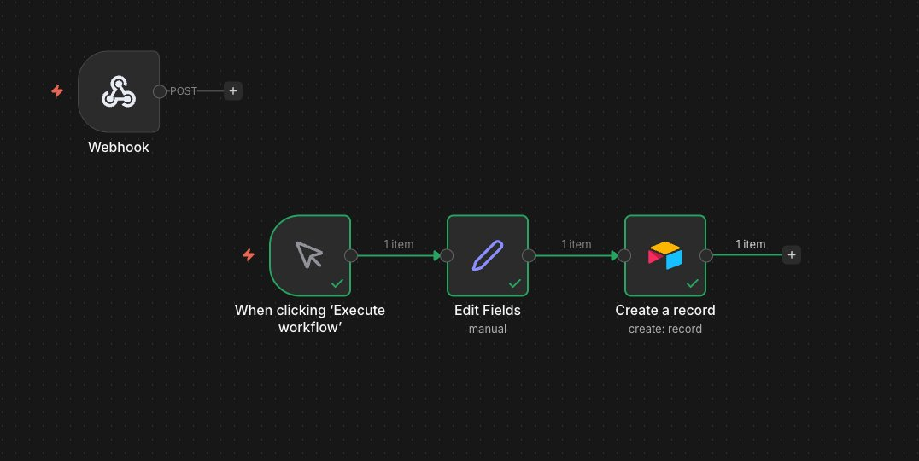
Figure 1: n8n workflow with all nodes connected and successfully executed

Screenshot 2: Webhook Node Configuration
The Webhook node is configured with HTTP Method POST and path 'discord-logger'. The Respond setting is set to 'When Last Node Finishes', which means n8n waits for the full workflow to complete before sending a response back to the caller. This is the correct setting for a logging workflow.

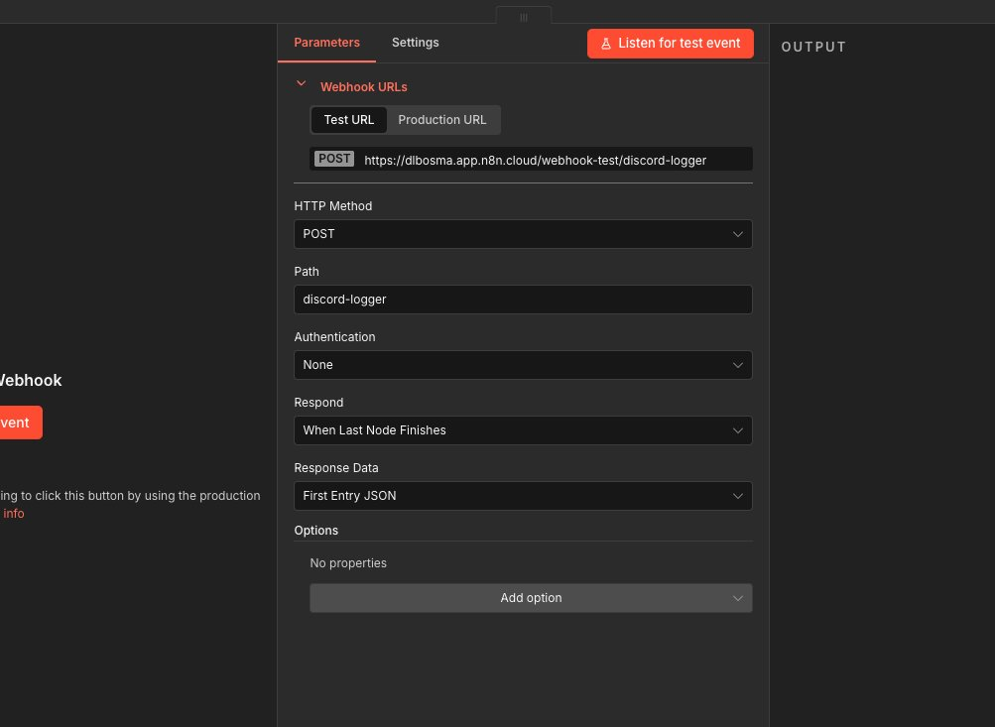
Figure 2: Webhook node configuration (POST, path: discord-logger, ready for Discord connection)

Screenshot 3: Airtable Tracker with Logged Entries
The Airtable base shows three successfully logged entries in rows 15, 16, and 17. Each row contains a Timestamp (ISO format), Client Name, Channel ID, Question text, and Status set to 'New'. The workflow was executed three times with the same test data to confirm consistent, reliable logging.

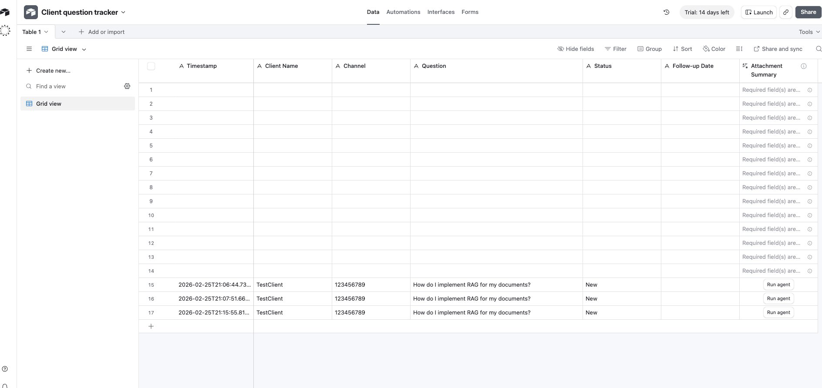
Figure 3: Airtable 'Client question tracker' with 3 logged test entries confirming end-to-end workflow success

Success Criteria Check

Criteria | Status
Successfully created n8n workflow | Done
Discord messages / test data logged to tracker | Done (Manual Trigger with test data)
Data is correctly formatted | Done
All columns are populated correctly | Done
Workflow executes without errors | Done

How the Data Was Transformed
The Edit Fields (Set) node served as the translation layer between the Discord message format and the Airtable column structure. Each field was explicitly defined in the Set node:

Timestamp = {{ $now.toISO() }}
Client Name = {{ $json.username }}
Channel = {{ $json.channel_id }}
Question = {{ $json.content }}
Status = New

The key insight here is that the Set node decouples the source format from the destination format. Discord sends fields like 'content' and 'username', but Airtable expects 'Question' and 'Client Name'. The Set node bridges that gap.

The Timestamp required special handling. The standard {{ $now }} expression returns an n8n DateTime object, but Airtable's Date/Time field expects an ISO 8601 string. Adding .toISO() converts it to the correct format (e.g., 2026-02-25T21:06:44.730Z).

The Airtable node was set to 'Map Automatically' mode, which matched the Set node's output field names directly to the corresponding Airtable column headers. This requires that the field names in the Set node match the column names in Airtable exactly.

Challenges Encountered
Several issues came up during setup that required debugging. Each one was resolved systematically:

- Airtable API token permissions: The token initially lacked the schema.bases:read scope, which meant n8n could connect to Airtable but could not load the column names. This was fixed by adding the scope in Airtable's token settings and refreshing the connection in n8n.
- Incorrect Base ID format: Pasting the full Airtable URL into the Base field caused a 404 error. The fix was to switch to 'By ID' mode and enter only the app... and tbl... identifiers extracted from the URL.
- Timestamp format mismatch: Airtable rejected the raw $now value because it was not in ISO string format. Changing the expression to $now.toISO() resolved this.
- Empty fields on first Airtable test: The Airtable node was initially set to manual mapping mode with no fields configured. Switching to 'Map Automatically' resolved this immediately.
- Discord Trigger not available: The Discord Trigger node is not available in this version of n8n Cloud. A Discord bot was created and successfully added to the server as proof of concept. The workflow uses a Manual Trigger with test data in the meantime. In a production setup, the Discord Trigger node or a webhook middleware would replace this.

Troubleshooting Log

Error | Cause | Fix
NOT_FOUND (404) on Airtable node | Full Airtable URL pasted into Base field instead of Base ID | Switched to 'By ID' mode and used only the app... and tbl... IDs
No columns found in Airtable | API token missing schema.bases:read scope | Added the scope in Airtable token settings, then clicked Retry in n8n
Request invalid or could not be processed | Timestamp value not matching Airtable Date/Time format | Changed Set node Timestamp from {{ $now }} to {{ $now.toISO() }}
Records created with empty fields | No field mappings configured in manual mapping mode | Switched Airtable node to Map Automatically mode
Discord Trigger not available | Node not available in this version of n8n cloud | Used Manual Trigger with test data; Discord bot created as proof of concept

How This Workflow Could Be Extended
- Connect a real Discord Trigger once the node becomes available in n8n, replacing the Manual Trigger with live message capture.
- Add an IF node to filter messages and only log those containing keywords like 'help', 'question', or 'issue'.
- Use an AI node (e.g., OpenAI or Claude) to auto-categorize questions by type: technical, billing, or general.
- Add a notification node to send a Slack or email alert when a new high-priority question is logged.
- Add deduplication logic using an IF node to check whether the same question content has already been logged before appending.
- Add a 'Responded' column to Airtable and update it automatically when the consultant sends a reply.

Comprehensive Summary

What We Built
A multi-app integration workflow in n8n that automatically captures client questions and logs them to a structured Airtable tracker. The workflow eliminates manual data entry and creates a reliable, timestamped log for follow-up and analysis.

Step-by-Step Recap
- Created the Airtable base 'Client question tracker' with columns: Timestamp, Client Name, Channel, Question, Status, and Follow-up Date.
- Built an n8n workflow named 'Discord to Google Sheets Logger' with three active nodes: Manual Trigger, Edit Fields (Set), and Airtable Create Record.
- Configured the Webhook node with path 'discord-logger' for future production use.
- Set up the Edit Fields node to map Discord-style fields (content, username, channel_id) to Airtable column names (Question, Client Name, Channel), with $now.toISO() for the Timestamp.
- Resolved four configuration errors through systematic debugging (API scope, Base ID format, Timestamp format, and mapping mode).
- Executed the workflow three times and confirmed all entries appeared correctly in Airtable.
- Created a Discord bot and added it to a server as proof of concept for the eventual production connection.

Key Concepts Learned
- The Set / Edit Fields node is the backbone of multi-app integration: It translates one system's data format into another's, and keeping this logic in one dedicated node makes the workflow easy to debug and maintain.
- {{ $now.toISO() }} vs {{ $now }}: Always check the expected data format of the destination system. Airtable requires ISO 8601 strings for Date/Time fields, not raw DateTime objects.
- API token permissions matter: When connecting to APIs like Airtable, the token must include the correct scopes. Missing a single scope can cause confusing errors that are not obviously permission-related.
- Map Automatically mode in Airtable: When field names in the Set node match Airtable column names exactly, 'Map Automatically' eliminates the need to manually configure each field mapping in the Airtable node.
- Test before connecting live systems: Using a Manual Trigger with sample data before connecting real Discord is best practice. It lets you verify the entire pipeline works without depending on external services.
- Idempotency awareness: Running the same workflow multiple times produced duplicate rows, which is expected behavior for an Append/Create operation. In production, a deduplication check would prevent this.

